Click Here, Type the Title of Your Paper, Capitalize Each Word
(14pt, bold)

First Author (12pt, bold)
Short biography (Department, affiliation, country) (12pt, italic)

Second Author (12pt, bold)
Short biography (Department, affiliation, country) (12pt, italic)

Third Author (12pt, bold)
Short biography (Department, affiliation, country) (12pt, italic)

Abstract (12pt, bold)
Abstract must provide information on the topic description, theoretical focus, objectives, study area, data and research methods, expected findings, and significance. Abstract should be approximately 150-250 words in length. Abstract must provide information on the topic description, theoretical focus, objectives, study area, data and research methods, expected findings, and significance.
(12pt, single line spacing, 1 paragraph)

Keywords (12pt, bold): The limit of the keywords is 3-5 words, Writing, Skills, Grammar, Manuscript (12pt)

Introduction (12pt, bold)
The introduction should contain the general background and research question or hypothesis. (12pt, 1,5 line spacing)

Literature Review (12pt, bold)
The literature review should certain a written overview of major writings and other sources of the selected topic. It should provide a description, summary, and evaluation of each source.

Methods (12pt, bold)
The research methods should elaborate on the method utilized in addressing the issues including the method of analysis.

Results and Discussion (12pt, bold)
The results and discussion section should present the result of research, key findings with respect to the research question in the introduction, state and discuss the main findings of the study, analyze the strength and limitations, and offer perspectives for future work.

Conclusion (12pt, bold)
The conclusion should contain a brief summary and suggestion.

References (12pt, bold)
Author(s) are responsible for ensuring that the information in each reference is complete and accurate. All references should be cited within the text; otherwise, these references will be automatically remove. For articles published, please followed the APA 6th edition. Authors are strongly urged to use a reference manager such as Mendeley, Zotero or Endnote to build their references.
Books
Johnston, M. (2009). Perspective, persistence, and learning. Thaosand Oaks, CA: Sage.

Book chapter
Richards, K. C. (1997). Views on globalization. In H. L. Vivaldi (Eds.), Australia in Global World (pp. 29-43). Sydney, Australia: Century.

Journal article
Jackson, A. (2007). New approaches to drug therapy. Psycology Today and Tommorow, 27(1), 54-59.

Journal article with DOI
Elo, A., Ervasti, J., Kuosma, E., & Matilla, P. (2008). Evaluation of an organizational stress management program in a municipal public works organization. Journal of Occupational Health Psychology, 13(1), 10-23. doi: 10.1037/1076-8998.13.1.10.

Journal article retrieved from database without DOI
Romalho, M., Da Silva, G., Dias, L. (2009). Genetic plant improvement and climate changes. Crop Breeding and Applied Biotechnology, 9(2), 189-195. Retrieved from http://www.sbmp.org.br/cbab

Newspaper article
Fung, M. (2006, December 12). Asthma rates are increasing. Winnipeg Free Press, pp. C4, C7-C8.

Newspaper article on website
Darby, A. (2002, August 20). Rarest tiger skin a rugged survivor. Sydney Morning Herald. Retrieved from http://www.smh.com.au

Website
Buzan T. (2007). Mind maps. September 3, 2009, retrieved from http://www.buzanworld.com/Mind_Maps.html.

Website document
TransCanada. (2006). Annual report. Retrieved from http://www.transcanada.com/investor/annual_reports/2006/media/pdf/TransCanada_2006_ Annual_Report.pdf

Book translation
Mancusa, S., & Viola, A. (2015). Brilliant green: the surprising history and science of plant intelligence (J. Benham, Trans.). Washington, DC: Island Press.

- Example of Figures and Tables

Table 1. Type Table’s Title (Title of Table 11pt, bold, italic)
Table Head | Table Column Head | Table Column Head
Copy | More table copy | More table copy
(Source: obtained from data (11pt))

- Positioning Picture/Figures/Diagram
Picture/Figures/Diagram should be supplied in either vector art formats (illustrator, EPS, WMF, FreeHand, CorelDraw, PowerPoint, Excel, etc.) or bitmap formats (Photoshop, TIFF, GIF, JPEG, etc.). Bitmap images should be of 300 dpi resolution.
Large picture/figures/diagram may span across both columns. Figure captions should be below the figures. Insert figures after they are cited in the text. Use the following example as an illustration.
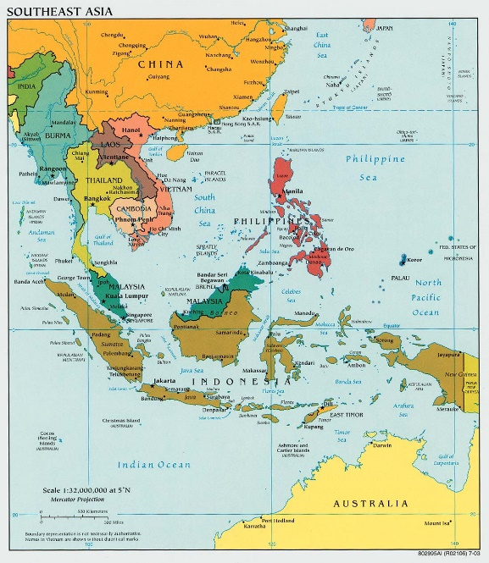
Picture/Figures/Diagram 1(italic, 11pt, bold). Type Figure’s Title (11pt, bold)
(Source: Author(s), 2008, p.1 (11pt))

Acknowledgement
All acknowledgements (if any) should be included at the very end of the paper before the references. These may include supporting grants, presentation, and so forth. While the advice and information in the journal are believed to be true and accurate on the date of its going to press, neither the authors, the editors, nor the publisher can accept any legal responsibility for any errors or omissions that may be made. The journal makes no warranty, express or implied, with respect to the material contained herein.

Corresponding e-mail (10pt, italic)
Corresponding e-mail
Corresponding e-mail

